Assigment RESTfull(douc)

Dr.Amjad abu Hassan

Yazan lubbadeh,Ezz Addin kukhun,Ameer yaish

We have been using spring boot framework and MySQL database.

The APIs:

1-Signup

URL: http://localhost:9090/addUser (POST)

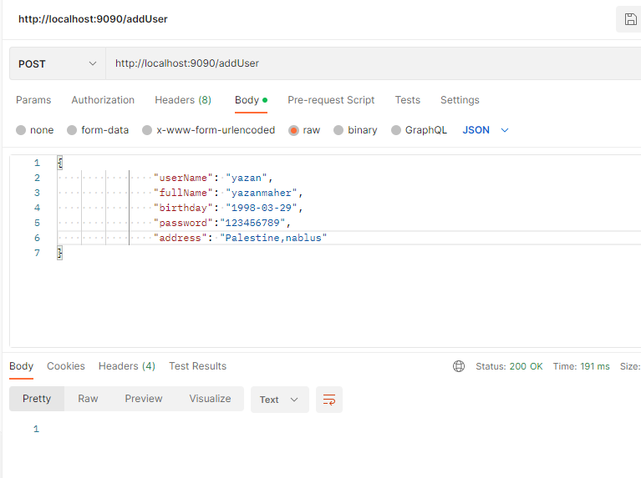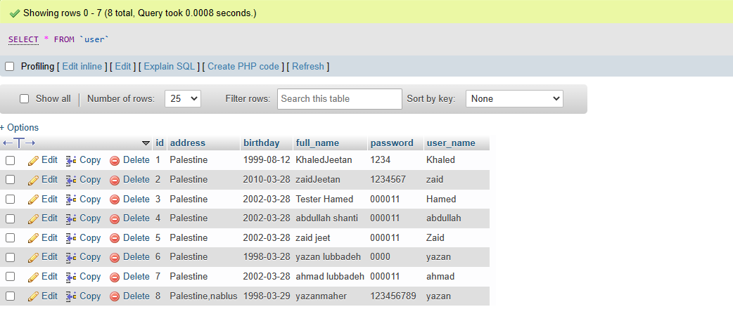

2-login

URL: <http://localhost:9090/login> (GET)

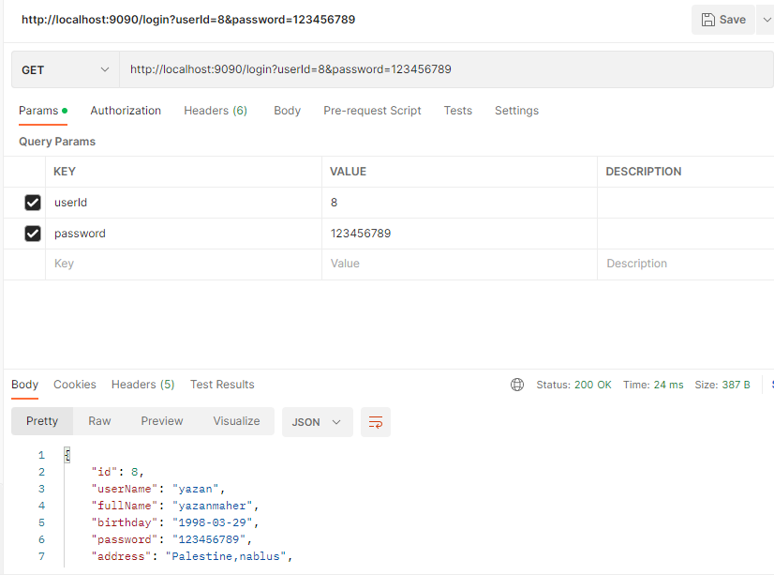

3- Add New Tweet

URL: <http://localhost:9090/addNewTweet> (POST)

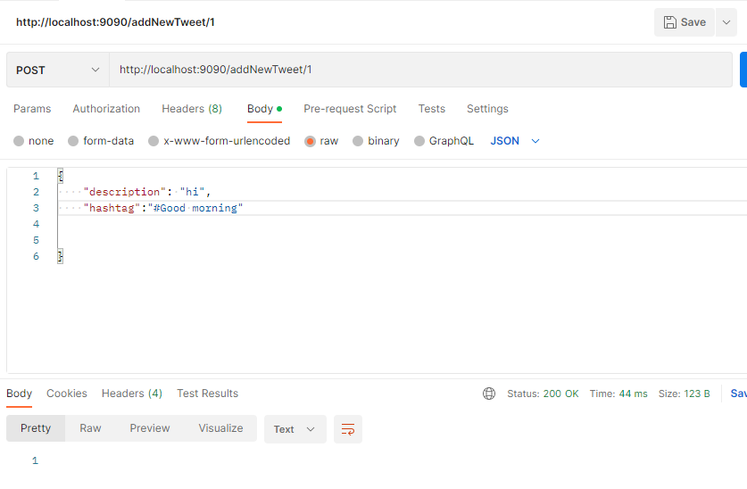

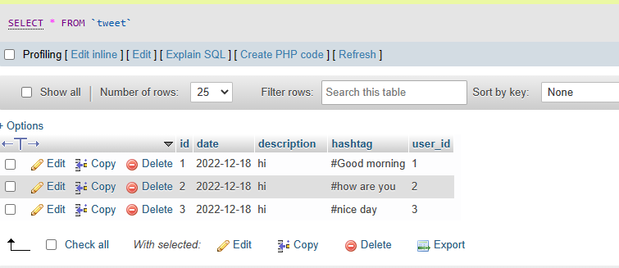

4- Delete a tweet

URL: <http://localhost:9090/deleteTweet> (DELETE)

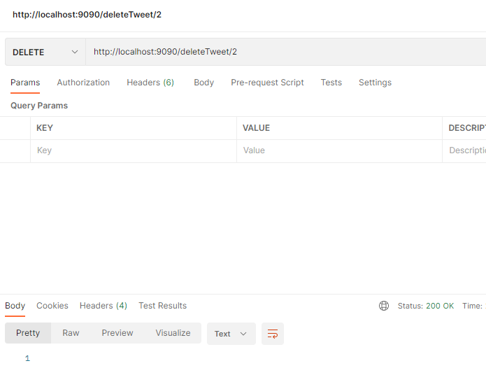

5- Edit a Tweet

URL: <http://localhost:9090/editTweet> (PUT)

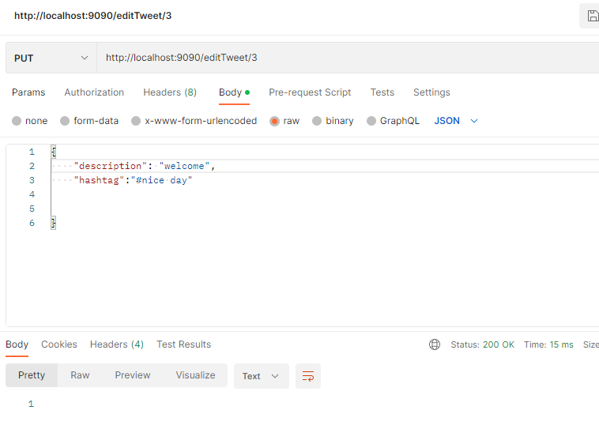

6- Retrive all tweets

URL: <http://localhost:9090/gettweets> (GET)

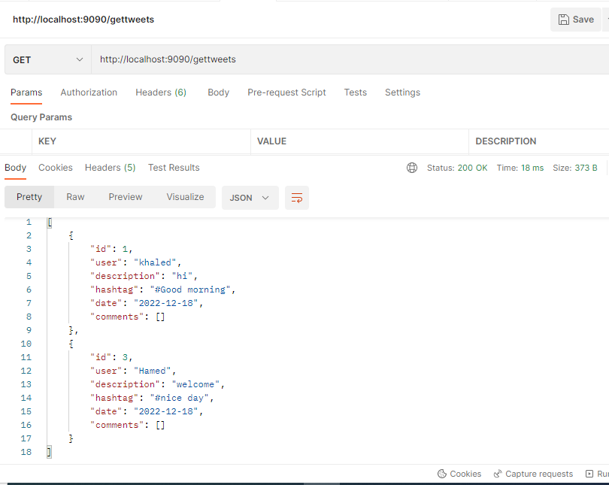

7- Retrive specific user tweets

URL: <http://localhost:9090/getUserTweets/1> (GET)

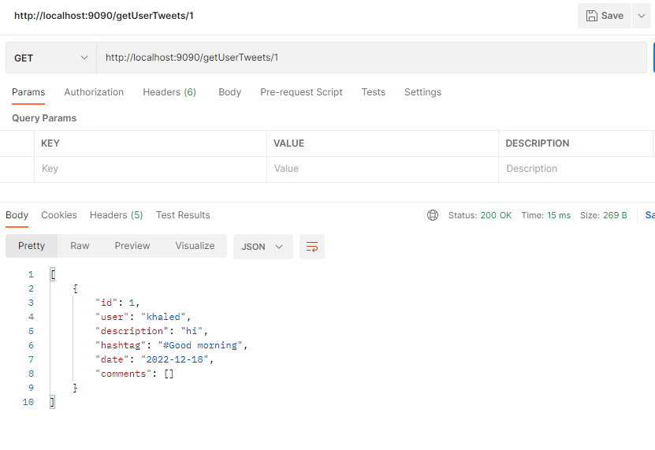

8- Retrive user info

URL: <http://localhost:9090/getSpecificUserInfo/8> (GET)

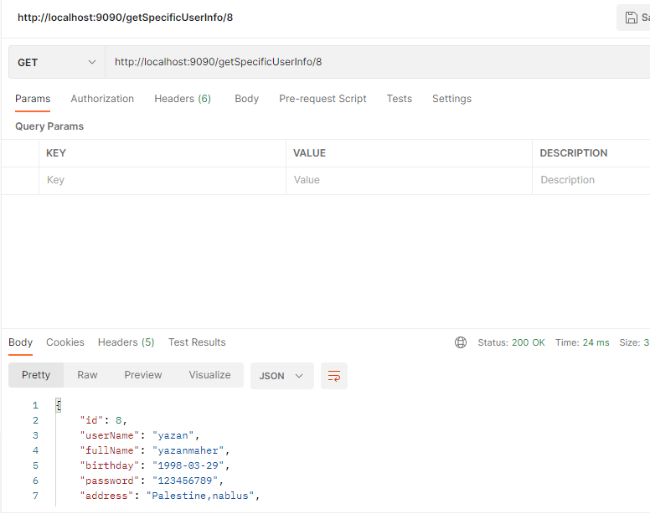

9- Edit my own info

URL: <http://localhost:9090/editUser/8> (PUT)

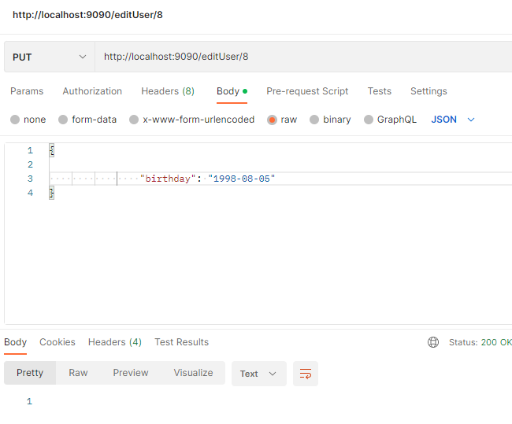

10- Ghange Password

URL: <http://localhost:9090/changePassword/4> (PUT)

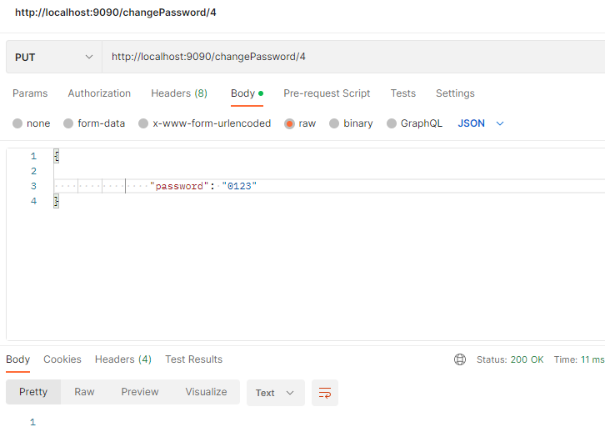

11- Follow a User

URL: <http://localhost:9090/followUser?followerId=1&followedId=2> (PUT)

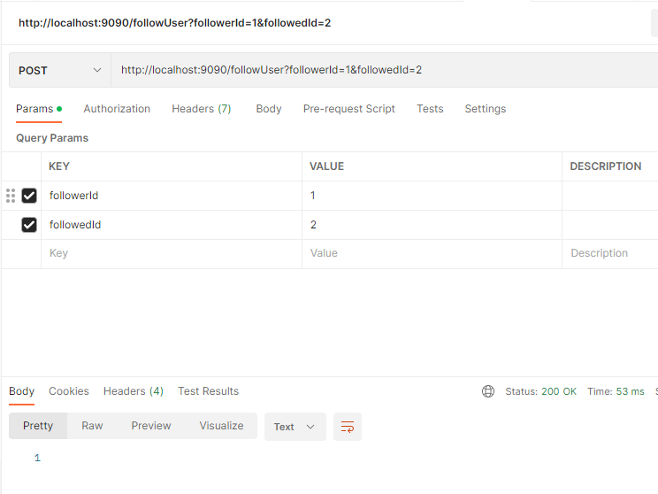

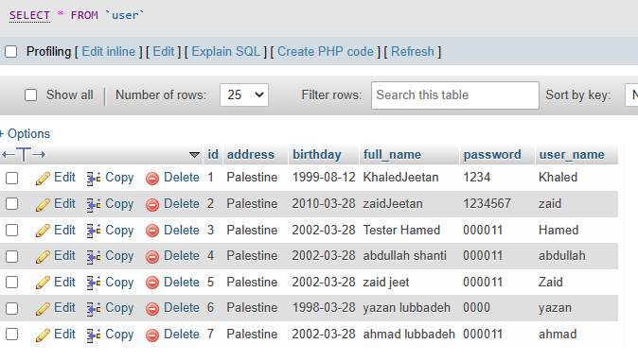

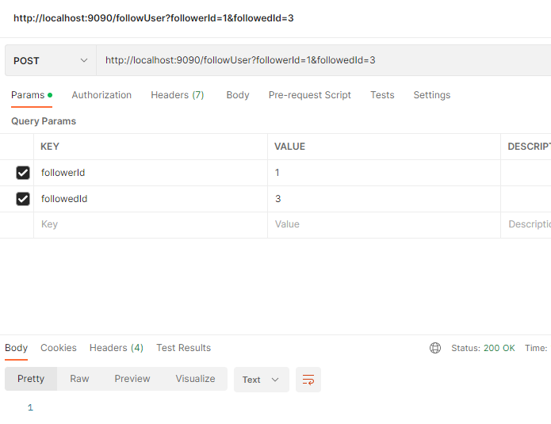

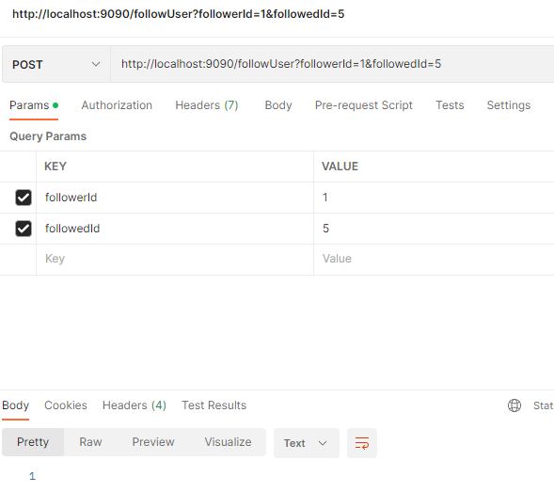

12- Un Follow a User

URL: <http://localhost:9090/unFollowUser?followerId=1&followedId=3> (PUT)

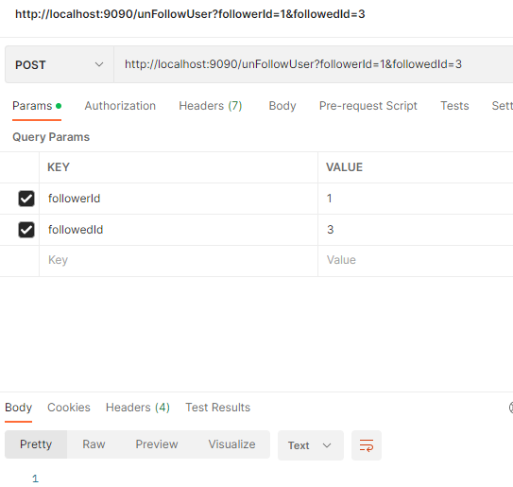

13- Retrive Followed User Tweets

URL:<http://localhost:9090/getUserFollowed/1> (GET)

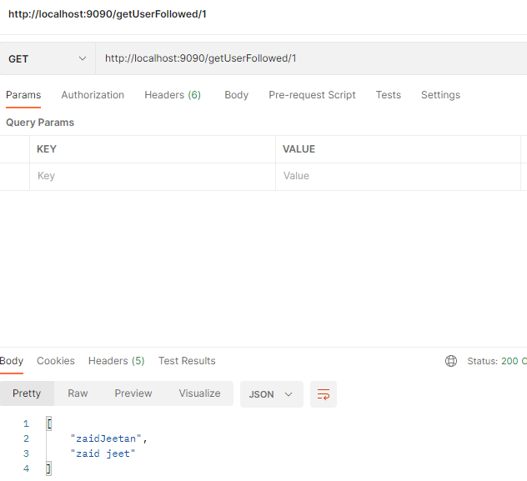

14- Add Tweet to a saved list

URL: <http://localhost:9090/saveTweet?userId=1&tweetId=7> (POST)

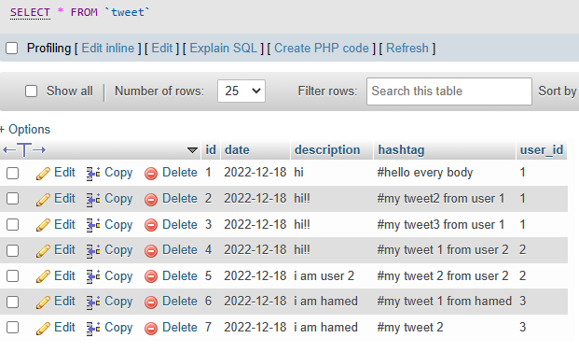

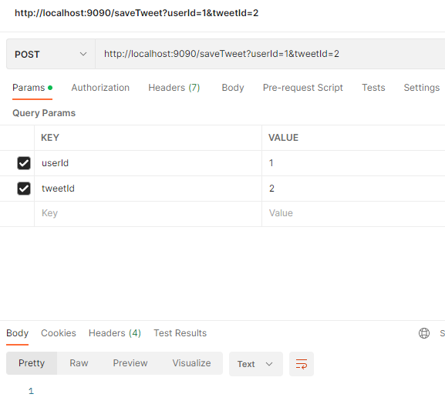

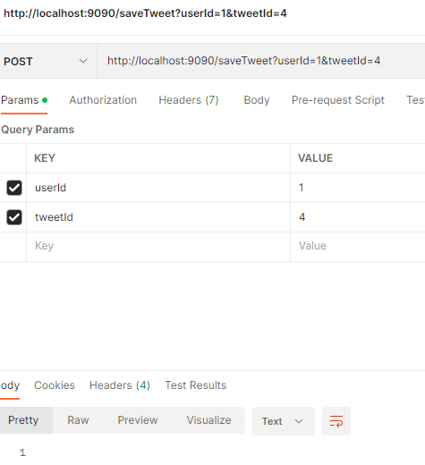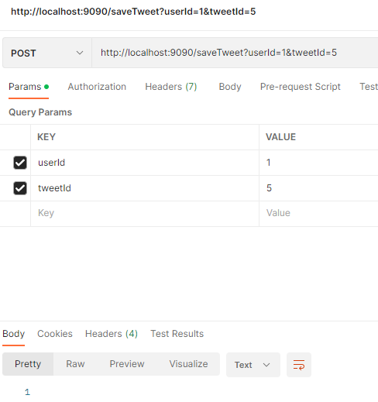

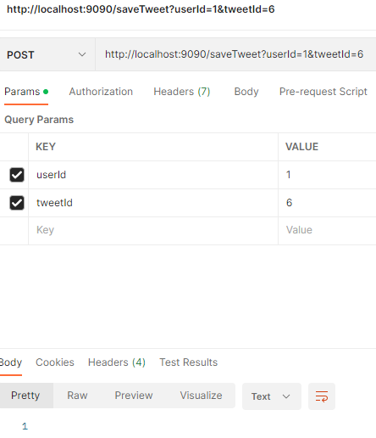

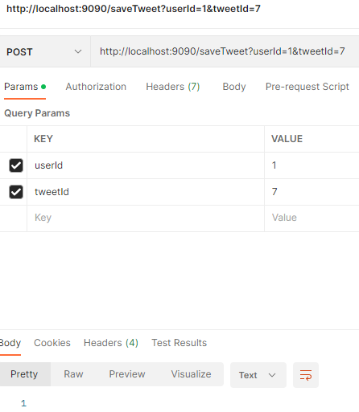

In the pictures show user 1 saved tweets (2,4,5,6,7)

15 – Delete tweet from the saved list

URL: <http://localhost:9090/deleteSavedTweet?userId=1&tweetId=5> (POST)

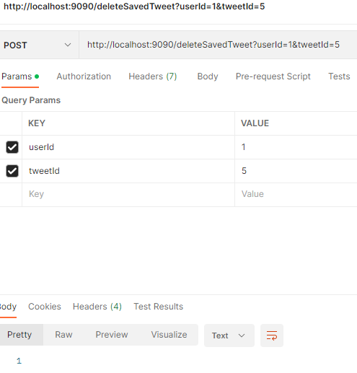

16- Retrieve the saved tweets

URL: <http://localhost:9090/getSavedTweets> (POST)

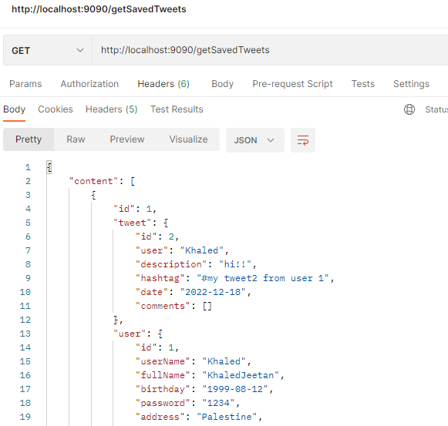 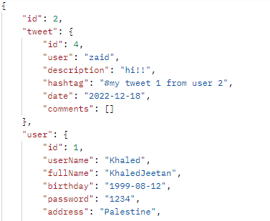

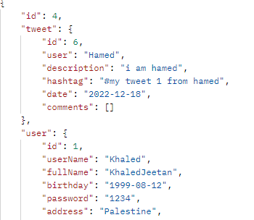 Use paging

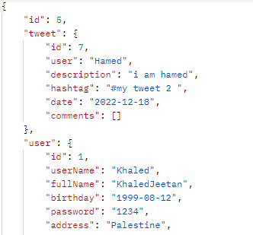 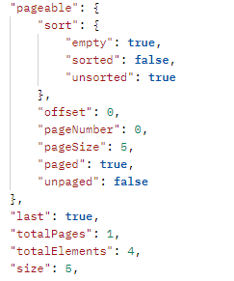

17- Hide a tweet

URL: <http://localhost:9090/hideTweet> (POST)

Tweet Table before hide/unhide

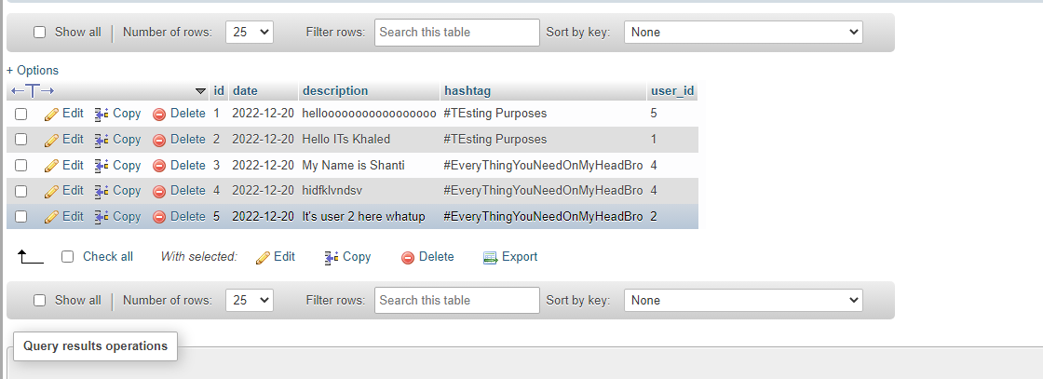

Hide tweet(3) from user(1)

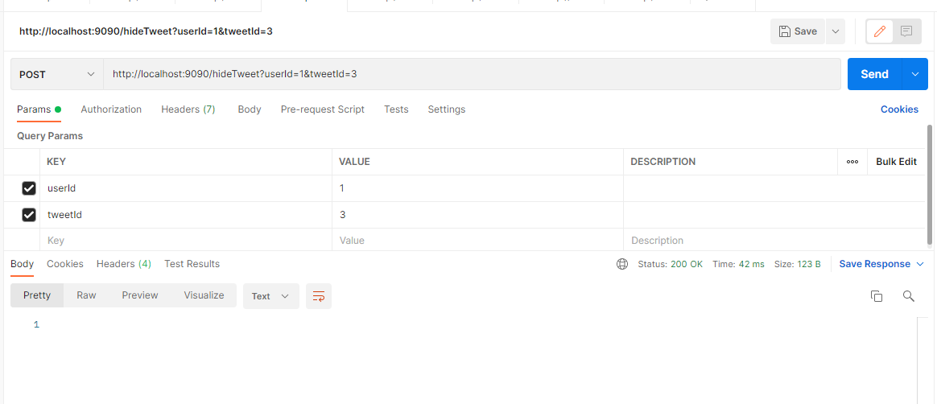

Hide tweet(1) from user(1)

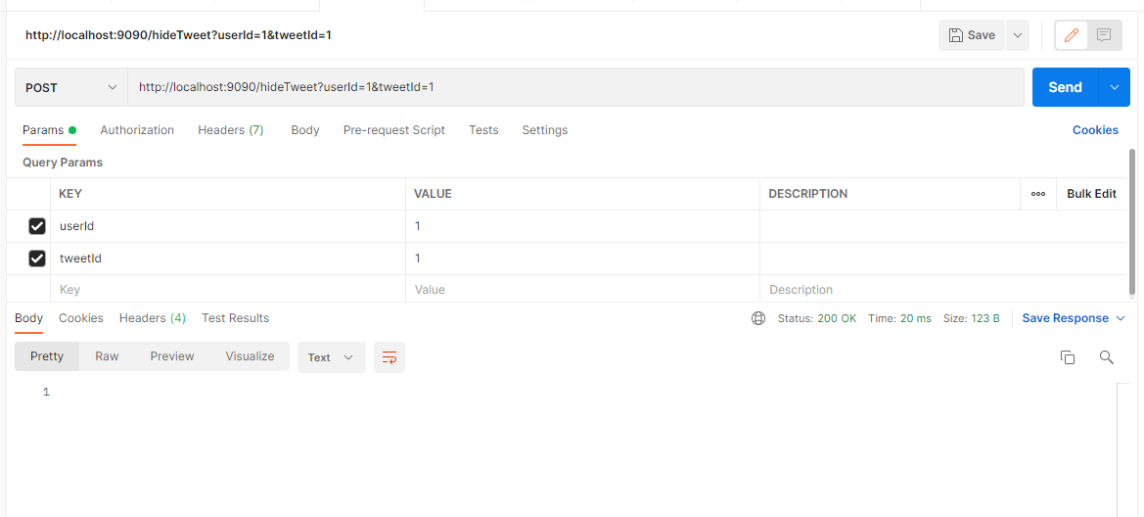

Retrieve Tweets Unhidden (User1)

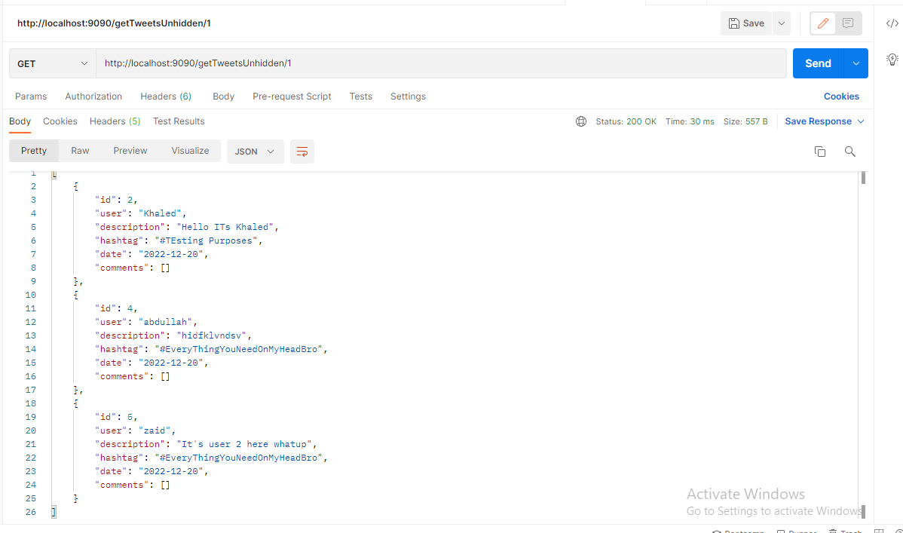

18- unhide a tweet

URL: <http://localhost:9090/unhideTweet> (DELETE)

Unhide tweet(1) from user (1)

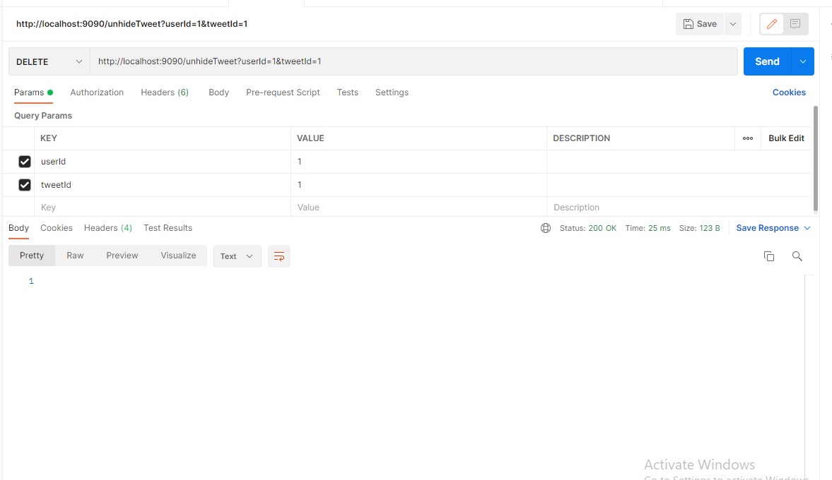

Retrieve Tweets Unhidden (User1) after unhide tweet(1)

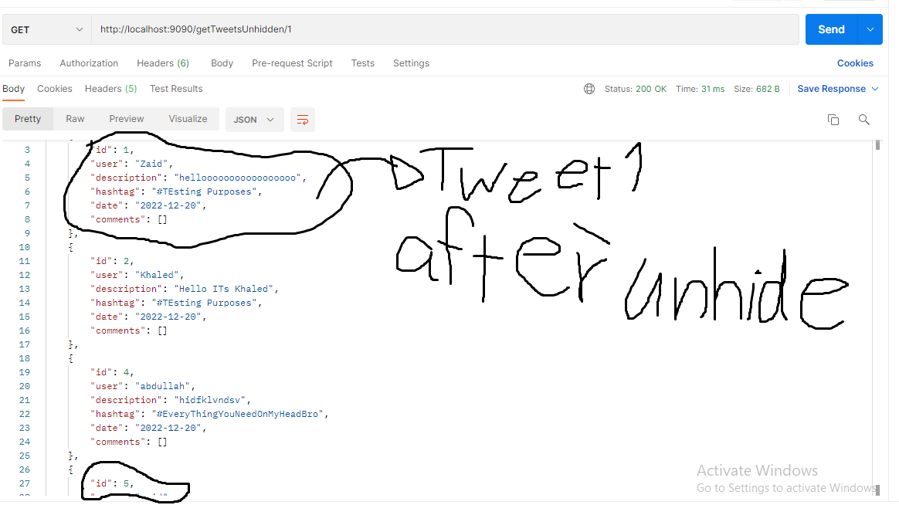

19- Comment on a tweet

URL: <http://localhost:9090/addComment> (POST)

User Table:

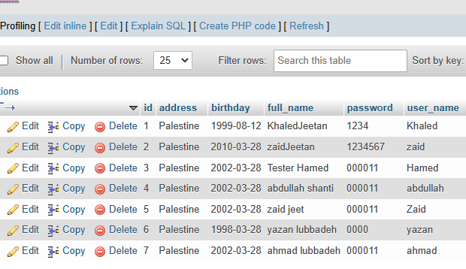

Tweets Table

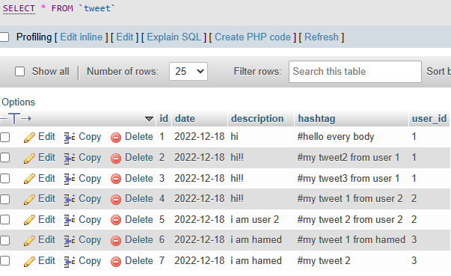

User id(7) 🡪 Comment on tweet id(6)

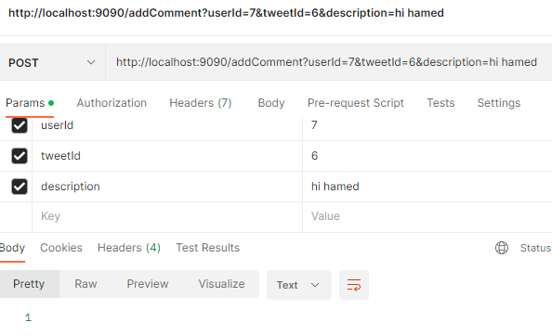

User id(7) 🡪 Comment on tweet id(2)

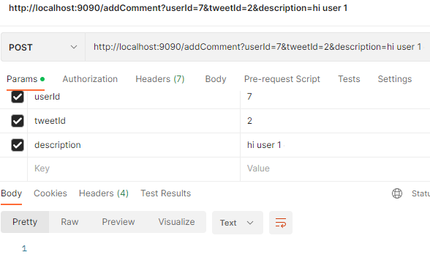

Retrieve user(7) comments

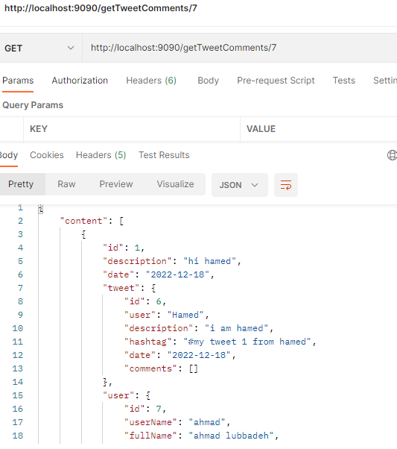

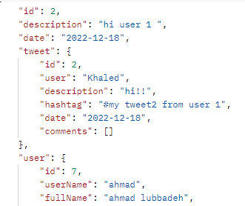

Use paging

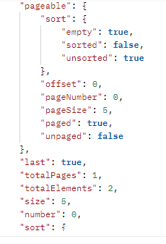

21- Delete a tweet comment

URL: <http://localhost:9090/deleteComment/1> (DELETE)

Comment Table

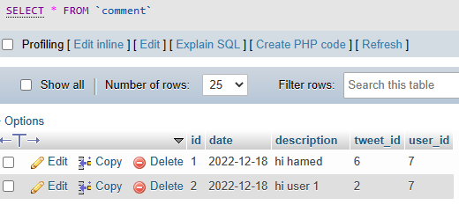

I will delete a comment(1)

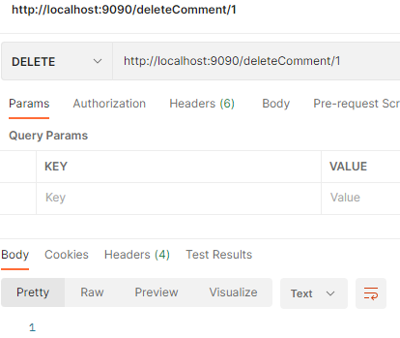

Comment Table after delete a comment(1)

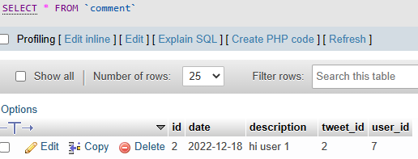

22- Like a tweet

URL: [http://localhost:9090/likeTweet](http://localhost:9090/likeTweet?userId=6&tweetId=1) (POST)

Tweet Table

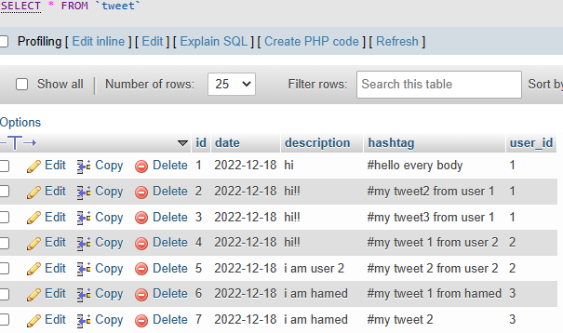

User Table

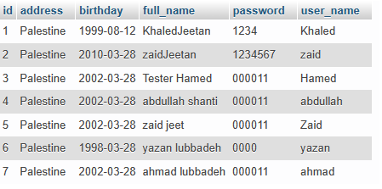

User(1) 🡪 like a tweet (1)

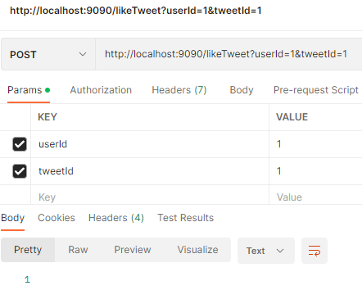

User(2) 🡪 like a tweet (1)

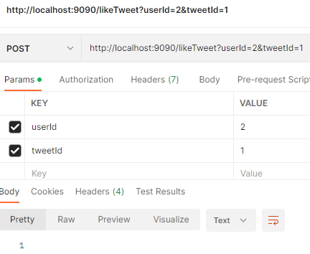

User(6) 🡪 like a tweet (1)

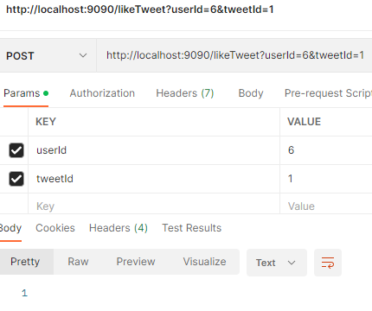

23- Retrieve tweet likes

URL: <http://localhost:9090/getTweetLikes> (GET)

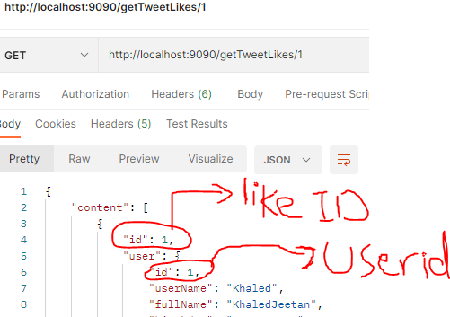

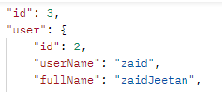

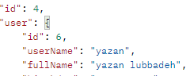

24- Unlike a tweet

URL: <http://localhost:9090/unLikeTweet> (DELETE)

Users(2,3,6,7) 🡪 like tweet(1)

User(2)🡪 unlike tweet(1)

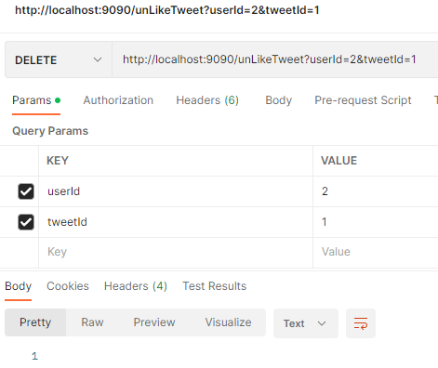

User(2) is unlike tweet

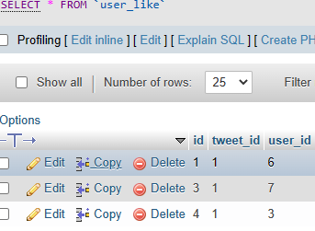

25- Retrieve tweet likes count

URL: <http://localhost:9090/getTweetLikesCount/1> (GET)

